Nepal College of Information Technology
Unit Test
Fall 2011
Program : BE Time : 2 hrs
Semester : Fall (II) FM : 70
Subject : Engineering Math-I PM : 35

- Candidates are requested to give their answer as far as practicable in their own words.
- The figure in the margin indicates the full marks
- Attempt ALL question
1. Integrate the followings: 5*3=15
a) 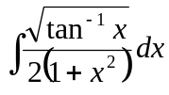
b) 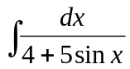
c) 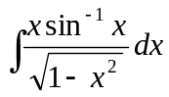
2. Integrate:
a) 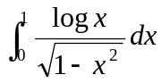 5
b) 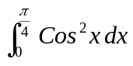 (by Summation method) 5
c) Find the area bounded by the curves y = sinx, y = cosx & the line y-axis in the first quadrant. 5
3. a) Find the area bounded between the parabola x² = 4y and the curve 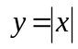 7
OR
Find the volume of the solid generated by revolving the region in the first quadrant bounded above by the parabola y = x², below by the x-axis and on the right by the line x = 2 about y-axis.
b) Use simpson’s and Trapezoidoil rule with n = 4 to approximate the area between the curve y = (2x+1)² ordinates at x = 1, x = 3 and x-axis. Compare these results with exact value. 8
4. a) Prove that 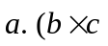) represents the volume of parallelepiped whose sides are 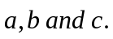 What conclusion can you draw about these vectors if 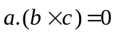. 7
b) Find an equation for the plane through the points (1, 1, -1), (2, 0, 2) and (0, -2, 1). 8
5. Short questions: 2*5=10
a) Evaluate 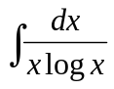
b) Determine the value of are perpendicular.
c) Find the length of the curve
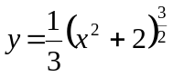 from x = 0 to x = 3.
- Show that
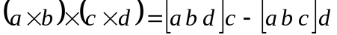
e) Evaluate 